ABSTRACT

Chemotherapy is a common treatment for breast cancer patients; however, this process does not produce consistent results across different patients. Whilst the treatment can be very beneficial, it is also very harmful to the patient, therefore uncertainty exists whether the treatment will be worthwhile for the individual as it is not guaranteed to work. By using machine learning on patient clinical and MRI scan data, the effectiveness and outcome of chemotherapy treatment may become more predictable.

1. Introduction

The use of Machine Learning (ML) to diagnose patients presents an opportunity to develop ML models capable of impacting the lives of many people. Chemotherapy is a physically and emotionally difficult experience for many people, understanding how an individual will respond to treatment allows for informed decisions to be made by both doctors and patients.

It can often be challenging for a doctor to accurately diagnose a patient given the complexity of the relationship between the factors which affect the outcome of treatment. ML is uniquely suited to explore large amounts of data to determine underlying patterns and aid in making accurate predictions.

In this paper, different ML methods are training on data pertaining to a small, highly dimensionally dataset used in both regression and classification tasks with the aim at predicting a patients pCR results (classification) and their relapse-free survival in months. (regression).

The first half of chemotherapy treatment prediction modelling is a patients pCR result which is used to diagnose the presence of cancer cells and is used as a tool for monitoring the effectives of cancer treatment.

The second half of chemotherapy treatment prediction modelling is relapse-free survival (RFS) time. By being able to predict the RFS, the patient would be better informed on both the effectiveness and potential value of the treatment, therefore being able to make an informed decision on chemotherapy as a treatment.

2. CLASSIFICATION

2.1. Literature Review

Many studies on breast cancer implement ML algorithms for classification. While many models can be used as classifiers, for a dataset of similar characteristics it was found that tree-based methods such as gradient boosted decision trees [1] and random forest [4] performed best when classifying.

Other work shows the promising results of using neural network approaches to classification due to their ability to learn complex relationships where many features are present. [8] One issue with neural networks is that they are often prone to overfitting, and they typically favour working with large amounts of data. There are certain strategies however that can be adopted to deal with overfitting, particularly carefully selecting the hyperparameters of the network [9].

2.2. Methodology

Prior to developing models for classification different methods were used to observe the data. Histograms were used to view the distribution of relevant features of the participants. All features were visualized using boxplots. It was observed that several of the binary classification samples were invalid (did not contain a value of 1 or 0).

Various models were explored logistic regression with both forward feature selection (FFS) and sequential feature selection (SFS). Given the promising findings of the literature review, decision trees, random forest (RF) and an ensemble method gradient boosted trees (GBT) were tested. An iterative method was used to determine the optimal depth for decision trees.

Gradient boosted decision trees were used with K-Folds cross validation to determine the best parameters. The number of estimators, max depth, min samples split, and min samples leaf were evaluated using grid search.

For the implementation of a neural network (NN) To preserve data quality these samples were removed. Outliers were clipped at the 99th percentile, the data was also normalized to ensure equal weighting between features and facilitate converging and improve the model’s ability to generalize to unseen data. The network architecture was constructed using the PyTorch library. To optimize the performance of the neural network, K-Folds was used to tune the model’s hyperparameters. A loss and validation curve were plotted to monitor the progress of training and guide the decision-making process for building neural networks.

The number of hidden layers, learning rate and L2 regularisation was evaluated using grid search. Dimensionality reduction (DR) was also explored during the training of the NN where Principal Component Analysis was used to reduce the highly dimensional dataset. A spree graph was used to determine the number of features to preserve a variance of 95% in the data. The architecture of the neural network was also explored by changing the activation function. Recall, f1 and balanced accuracy score was used for the evaluation of categorical data.
 | Recall | F1 | Balanced Accuracy
Logistic Reg. | 0 | 0 | 0.5
Decision Trees | 0.151 | 0.178 | 0.522
Random Forrest | 0.066 | 0.105 | 0.527
Gradient Boosted Trees | 0.157 | 0.261 | 0.571
Neural Networks | 0.579 | 0.423 | 0.606
Table 1: optimal model permutation results from 5 k-fold validation for training and test sets.

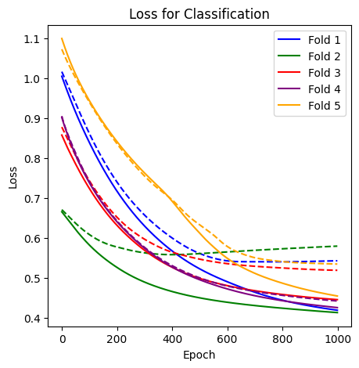
Figure 1: Sigmoid NN loss across k-fold validation

2.3. Model Analysis

Logistic regression performed the worst, FFS and SFS only selected 1-2 features which was not enough to capture underlying patterns in the data. DT and RF performed similarly also not performing well in either 3 of the metrics evaluated.

NNs were particularly prone to overfitting, they had to be tuned by observing validation curves. The number of hidden layers and the L2 regularisation were adjusted to select the best performing model. It was found that increases in model complexity led to worse performing models. The most effective strategy to improve model performance was early stopping which prevented overfitting of the model.
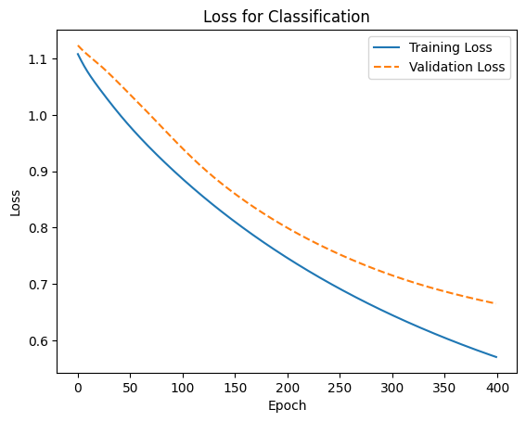
Figure 2: Sigmoid NN loss for training and validation

Figures 1 and 2 show that for a standard NN with a sigmoid activation function. The graphs for training and validation help inform the design decisions of the NN. After noticing the validation loss was diverging too quickly the activation layer was changed from ReLu to sigmoid resulting in significantly better performance.

2.4. Conclusion

The highly dimensional and small dataset made it difficult for all models to perform well in the three metrics: recall, F1 score and balanced accuracy. NNs with 1 hidden layer, L2 regularisation of 0.001 and a learning rate of 0.01 over 1000 epochs performed best achieving a balanced accuracy score of 0.606. The model was trained on data which had been regularised and had PCA applied retaining 95% variance in the data. To improve the model’s performance using better feature selection techniques could result in better classification accuracy.

3. REGRESSION

3.1. Literature Review

A common problem in breast cancer ML modelling is that there is a lack of diversity in the data sets available [2], which means that different populations to those in the control group may not be compatible with the developed model. In addition, annotated data is relatively rare in the medical field [2], which means that supervised learning models will struggle to find a suitable amount of data without the funding to commission more. Although unlabelled data would be abundant, the complexity of categorising and labelling this data could prove harmful to
the models, therefore it would be safer to avoid any unlabelled data.

Most studies focus on the detection of breast cancer or determining the outcome of chemotherapy as a treatment. The few studies which do use regression to review breast cancer and chemotherapy rarely discuss any metric like RFS, which means that most hypotheses relating to regression models will need to be inferred. One of the popular models is RF due to its adaptability for regression and classification, in addition to its ensemble approach which should alleviate any potential model weaknesses [4]. Artificial neural networks are also efficient at classifying breast cancer relapse chances which makes it another key candidate [6]. Finally, SVM’s have been proven to be efficient at classifying breast cancer recurrence [7].

3.2. Methodology

The dataset included null and erroneous values. Due to the severely limited data set size, as well as concerns over model purity, the use of regression and classification should not be used for data imputation or normalisation, as this would result in overfitting for any model to use these features. Since most null values are attributed to binary features, a median approach was used and since the dataset does not have and missing RFS data points, no rows would need to be removed. Finally, key candidates for data normalisation for outliers, which primarily affect MRI data, are z-score due to its usage of standard deviation, and min-max as it allows for custom parameters. The primary concern for data normalisation is to avoid scaling any data sets, as this could result in mistranslation errors if the test data set is not scaled in the same manner as the training set.

Since no ‘best’ model was found for this task, various permutations for feature selection and learning models should be tested across various models. During which, models will be evaluated using mean absolute error (MAE = (1/n) ∑(i=1 to n) | y_i – ŷ_i | ).

K-Fold cross validation was used to validate the model's performance on various test sets.

3.3. Model Analysis

Linear regression was developed and used as a performance benchmark. Permutations of linear regression models were trained using different feature selection methods: forward feature selection (FFS), sequential feature selection (SFS), and LASSO. FFS was found to be inefficient at preventing the curse of dimensionality as it would select up to 17 features to be used. This would be remedied by adding an additional requirement wherein each new feature must improve the accuracy of the model by a specified percentage. On the other hand, SFS provided a much simpler selection of 2 features whilst also being marginally more accurate. Finally, LASSO provided the best result, however it also suffered from overfitting to a greater degree than the previous models without any considerable advantage.

The first SVM model tested utilised radial basis function (RBF), this model selected a singular feature which resulted in a weak performance due to the low correlation between individual features to RFS. A polynomial kernel SVM was also tested, it suffered from the curse of dimensionality, selecting thirteen features. To combat this a performance requirement for new features was introduced which reduced the feature count to 3 at an optimal 1% performance increase requirement per feature. Finally, sigmoid kernel SVM’s did not suffer from the curse of dimensionality during its feature selection with both FFS and SFS, however it still failed to produce a competitive accuracy compared to linear regression.

Decision trees provided a result like linear regression; however, its accuracy was severely limited by its shallow depth, and lack of features used.

Subsequently, RFs also suffered from a lack of features, however they instead found deeper trees optimal which led to overfitting which can be seen in table 1, as its optimal feature count was 2, with a depth of 10. However, in the absence of a validation set, RFs generated the most accurate result, but with overfitting so severe the model would be unusable. If more data was available for training, RFs would likely be an optimal model.

Finally, multi-layer perceptron (MLP) neural networks were able to eliminate of overfitting through the usage of validation sets as the primary strength of neural networks is their adaptability of being able to adjust and tune hyperparameters. The primary hyperparameters for neural networks are the activation function for the hidden layer, the solver for weight optimisation, and the learning rate schedule, however this is only applicable for stochastic gradient descent (sgd) solvers. The secondary hyperparameters which need to be tuned are the quantity of neurons in the hidden layer, and the maximum number of iterations.

3.4. Conclusion

Although RF produced the lowest mean absolute error in its k-fold validation, it suffered from extreme overfitting. Consequently, RF was not suitable as a model for this task.

 | Avg. Training Error | Avg. Test Error
Linear Regression | 19.9 | 23.61
SVM | 21.86 | 25.67
Decision Tree | 21.91 | 24.86
Random Forest | 11.33 | 25.16
MLP NN | 22.31 | 22.56
Table 2: optimal model permutation results from 5 k-fold validation for training and test sets.

MLP neural networks allow for such a degree of hyperparameter tuning that overfitting can be easily and reliably reduced. From this testing it was found that the learning rate had a limited effect on sgd models, with both constant and adaptive learning rates producing identical outcomes, whereas invscale would always produce a model with no overfitting as well as usually having a lower MAE.

Despite not being a major factor across model permutations, the best performing activation function was logistic. In contrast, tanh suffered from inconsistent results with some solver permutations leading to extreme overfitting.

Solvers had the largest effect on hyperparameter tuning. Whilst adam preferred larger iteration values as it was designed for larger datasets, lbfgs preferred very few iterations (less than 10) as it was developed for smaller datasets, and lastly, sgd played a middle ground wherein the optimal number of iterations would lie in dozens to the low hundreds. This is reflected in sgd being the optimal solver for the size of the dataset used.

Whilst the solver did provoke the most hyperparameter changes in each model permutation, it also showed a key flaw and concern in the modelling process, and its attempt to achieve accuracy. Where the model could not achieve accuracy though its iterations, it would utilise additional hidden layer neurons to compensate for its inaccuracy. This would result in overfitting, both through having too many iterations, as well as too many hidden layer neurons. Consequently, the better the model can be fit through its iterations, the lesser the need for hidden layer neurons.

The best hyperparameters were found to be an activation layer of logistic, a sgd solver, and an invscaling learning rate. Although both constant and adaptive learning rates within this permutation suffered from minor overfitting (seen in table 2), invscaling suffered from no such issue, whilst also providing a significantly smaller mean absolute error. The final hyperparameters are max iterations, and hidden layer neurons in which a minor error can lead to a significant error increase. Since SGD runs optimally at a middling number of iterations, not much overfitting is seen from additional iterations, and this can be seen in figure3.
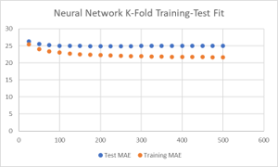
Figure 3: Neural Network training and test error correlation to max iterations for logistic, sgd, invscaling MLP NN model.

 | Avg. Training Error | Avg. Test Error
Relu | 22.502 | 24.965
Identity | 20.502 | 25.505
Logistic | 22.309 | 22.509
Tanh | 23.041 | 25.231
Table 3: comparison of 5 k-fold results for optimal permutations for each MLP NN activation function. These results are not representative of the final model’s performance.

A major issue that this model encounters is its lack of data in a complex field, thus having more data would likely allow for a better model to be developed, however the strength of neural networks is that an alternative hyperparameter would be able to accommodate any changes in the data set.

4. CONCLUSION

The small size of the dataset made it difficult to analyse the impact of data normalisation, While Z-score handles outliers well it impacts interpretability however min-max can achieve the same outcome without doing so.

NNs were shown to be effective for dealing with complex datasets, despite requiring a large amount of training data and being prone to overfitting some measures can be taken to mitigate the impact of the curse of dimensionality.

The main concern with using NNs for medical applications is the lack of interpretability, while performing best across all models tested the lack of transparency makes its adoption difficult in the field of medicine.

5. REFERENCES

[1] R. B. Mim, A. B. Islam, S. Roy, A. Sattar et al, “Breast Cancer Detection using Machine Learning Approach”, IEEE, ICECET Prague, Czech Republic, [ADD PAGE IF USING THIS REFERENCE],20-22 July 2022

[2] K. Meghana, N Nandal, R. Tanwar, L. Goel, G. Chhabra et al, “Breast Cancer Detection with Machine Learning-A Review”, IEEE, ICSCDS Erode, India, pp. 168, 23-25 March 2023

[3] S. Sharma, A. Aggarwal. T. Choudhury et al, “Breast Cancer Detection Using Machine Learning Algorithms”, IEEE, CTEMS Belgaum, India, [ADD PAGE IF USING THIS REFERENCE],21-22 December 2018

[4] M. S. Yarabarla, L. K. Ravi, A. Sivasangari et al, “Breast Cancer Prediction via Machine Learning”, IEEE, ICOEI Tirunelveli, India, pp. 122, 23-25 April 2019

[5] A. Chauhan, H. Kharpate, Y. Narekar, S. Gulhane, T. Virulkar, Y. Hedau et al, “Breast Cancer Detection and Prediction using Machine Learning”, IEEE, ICIRCA Coimbatore, India, pp. 1140, 2-4 September 2021

[6] P. Sankar, R. B. V et al, “Survival Analysis on Relapse Predictions of Breast Cancer using Optimized ANN and Deepsurv Model”, IEEE, IC3SIS Kochi, India, pp. 5, 23-25 June 2022

[7] K. Chakredo, S. Vyawahare, P. Pawar et al, “Breast Cancer Recurrence Prediction using Machine Learning”, IEEE, ICICT Allahabad, India, pp. 5-6, 6-8 December 2019

[8] N. Tariq, "Breast cancer detection using artificial neural networks," Journal of Molecular Biomarkers and Diagnosis, vol. 9, no. 1, pp. 1-6, 2017.

[9] T. Shaikhina and N. A. Khovanova, ‘Handling limited datasets with neural networks in medical applications: A small-data approach’, Artificial Intelligence in Medicine, vol. 75, pp. 51–63, 2017.

Task and Weighting | Data pre-processing (10%) | Feature Selection (25%) | ML method development (25%) | Method Evaluation (10%) | Report Writing (30%)
Bradley | 50 | 50 | 50 | 50 | 33
Isac | 50 | 50 | 50 | 50 | 33
Mohammed | 0 | 0 | 0 | 0 | 33
Simraan | 0 | 0 | 0 | 0 | 0
Alice | 0 | 0 | 0 | 0 | 0

